Spatiotemporal Variations in Macrozoobenthic Communities at the Mezitli Stream's Mouth
Ömer ŞAHBAZ¹ ⁽⁰⁰⁰⁹⁻⁰⁰⁰⁰⁻⁹¹²²⁻⁰⁰⁷³⁾, Anıl Alper AYDIN¹ ⁽⁰⁰⁰⁹⁻⁰⁰⁰⁶⁻¹²⁷⁶⁻⁵³⁵²⁾, Mert Can ACAR ^{1, 2 (0000-0002-2726-8416)}, Cengiz KORKMAZ^{2,3} ^{(0000-0001-7231-9983)*}, Deniz AYAS^{1, 2 (0000-0001-6762-6284)}
¹Mersin University, Faculty of Fisheries, Mersin, Turkey
² Mersin University Marine Life Museum, Mersin, Turkey
³Mersin Mezitli Municipality, Strategy Development Directorate, Mersin, Turkey
*Corresponding author: cngzkrkmz@hotmail.com

ABSTRACT
This study examines the ecological status of the Mezitli Stream mouth and highlights the effects of seasonal changes and pollution. Macrozoobenthic analyses revealed significant declines in species diversity during the dry season, especially at coastal stations, as indicated by low values of the Shannon-Weaver Diversity Index. Conversely, the rainy season was associated with increased water levels, improved oxygenation, and increased species richness and population density, particularly among gastropods and bivalves, including Alvania discors, Mangelia sp., Tellina sp., and Tritia pygmaea. The Azpollution Marine Biotic Index (AMBI) showed significant variability among sampling stations; Stations 5 and 6 exhibited the highest pollution levels. These sites were characterized by elevated nitrogen and phosphorus inputs from urban and agricultural sources, reduced dissolved oxygen, and the dominance of pollution-tolerant species, such as Nereis sp., Corbula gibba, and Hediste diversicolor, especially during the wet season. Oxidation-reduction potential (ORP) measurements corroborated these findings by indicating anaerobic conditions during the dry season, especially at stations 5 and 6. Rainfall during the wet season contributed to partial oxygen recovery in sediments, as indicated by less negative ORP values. Overall, the study demonstrates that seasonal shifts in oxygen availability and organic loading play a critical role in shaping the macrozoobenthic community structure of the Mezitli Stream.
Keywords: Macrozoobenthos, Biotic Index, AMBI, Shannon-Weaver Diversity Index, Mezitli Stream, Türkiye

INTRODUCTION

The conservation of biodiversity and the maintenance of ecological balance in aquatic ecosystems are critical to environmental sustainability. Elevated nutrient levels are a hallmark of many aquatic ecosystems, such as lakes, estuaries, and coastal zones, which provide conducive environments for diverse biological communities to thrive. However, the integrity of these ecosystems is increasingly threatened by anthropogenic stressors, including industrial discharge, agricultural runoff, and urbanization, which have led to water quality degradation and loss of biodiversity. Consequently, the practice of biological monitoring has become imperative for evaluating ecological health and facilitating effective ecosystem management (Dudgeon et al., 2006).
Macrozoobenthic organisms, defined as benthic invertebrates that exhibit a high degree of sensitivity to environmental changes, function as pivotal bioindicators within the framework of aquatic monitoring programs (Douterelo, Perona, & Mateo, 2004). The composition of species, abundance, and distribution of these organisms offer valuable insights into the ecological condition of aquatic systems. A plethora of biotic indices are in common use; among these are Shannon and AMBI (Azpollution Marine Biotic Index) (Borja & Muxika, 2005). The evaluation of ecosystem quality over time is facilitated by these indices, which employ diversity and pollution tolerance as their measuring sticks. These organisms, functioning as decomposers and secondary consumers, exhibit heightened sensitivity to factors such as oxygen availability, organic matter accumulation, and sediment structure, thereby serving as ideal indicators of ecological disturbances (Wallace & Webster, 1996).
This study investigates the spatial and seasonal variation of macrozoobenthic communities at the mouth of the Mezitli Stream, a hydrologically complex system originating from the Taurus Mountains and discharging into the Mediterranean Sea (Özay & Orhan, 2023). Notwithstanding the ecological significance of this stream, a conspicuous absence of systematic studies evaluating the benthic fauna and ecosystem health in this particular region is evident.
Seasonal hydrological shifts have been demonstrated to exert a substantial influence on the distribution of macrozoobenthic organisms. During the spring and summer months, decreased precipitation and nutrient input can potentially restrict oxygen availability, thereby affecting biological processes such as reproduction and development (Ge et al., 2025). Conversely, during the autumnal and winter months, elevated water volumes, concomitant with augmented organic matter influx, have been observed to promote heightened species richness and abundance. Furthermore, variations in sediment composition and redox conditions along depth gradients play a decisive role in shaping community structure, often favoring greater diversity in deeper, oxygen-rich environments (Vinson & Hawkins, 1998).
The primary objective of this research is to generate a current inventory of macrozoobenthic species in the Mezitli Stream mouth and to evaluate ecosystem health and pollution status across depth and seasonal gradients. The objective of the present study is to furnish essential ecological data that will underpin the implementation of biological monitoring practices and the development of informed conservation strategies for benthic habitats.

MATERIALS AND METHODS

The objective of this study was to examine depth-related variations and seasonal changes in macrozoobenthic communities at the mouth of the Mezitli Stream in Mersin, Türkiye. The research area is characterized by a transitional ecosystem that is subject to anthropogenic pressures, including agricultural runoff, industrial discharge, and urban pollution.
Sampling was conducted at six stations located (Figure 1, 2) where the stream enters the Mediterranean Sea during both the dry and wet seasons (Table 1). Sediment samples were collected using a Van Veen Grab sampler (de Almeida, Arana, Sant’Ana, & Pezzuto, 2016). Sediments were subsequently filtered through a 500 µm mesh sieve to separate macrozoobenthic organisms. The specimens were preserved in 10% ethyl alcohol and transported to the laboratory for analysis. The identification of species was conducted through the utilization of a binocular dissecting microscope. The abundance of each species were measured and recorded using an analytical balance. In addition to the collection of biological samples, Oxidation-Reduction Potential (ORP) was measured in sediment samples to assess oxygen availability and the degree of anaerobic conditions (Agarwal & Bui, 2017). This approach provided insights into environmental stress levels affecting benthic habitats.
Two ecological indices were utilized in this study: the Shannon-Weaver Diversity Index and the AMBI. The Shannon Index is a quantitative method that calculates species diversity based on relative abundances (Kunakh, Volkova, Tutova, & Zhukov, 2023). Alternatively, the AMBI assesses ecosystem health by classifying species into five pollution tolerance groups, ranging from sensitive to highly tolerant (Borja, Chust, & Muxika, 2019). These indices enabled the categorization of ecological status as healthy, slightly disturbed, moderately disturbed, heavily impacted, or degraded.
The objective of this study was to assess the ecological quality and pollution burden of the Mezitli Stream mouth by integrating biotic indices with physicochemical parameters, particularly ORP. The findings provide essential data for monitoring biodiversity and support the development of strategies for sustainable ecosystem management in the region.
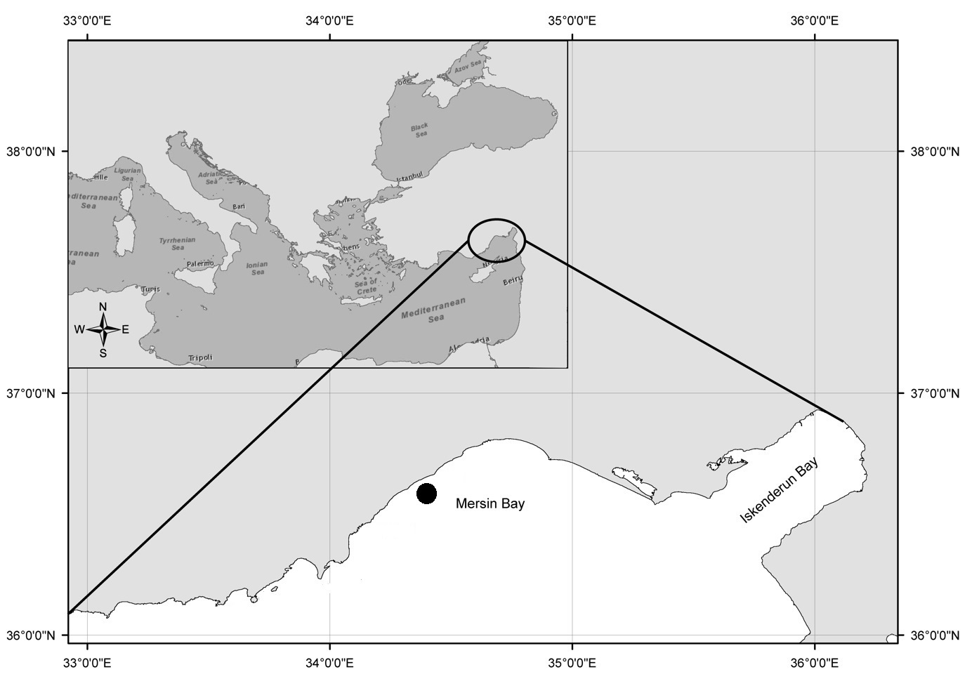Figure 1. Location of Mezitli Stream within Mersin Bay (eastern Mediterranean coast). The black dot indicates the sampling area situated along the Mezitli coast. The inset map shows the broader position of Mersin Bay within the eastern Mediterranean Sea.

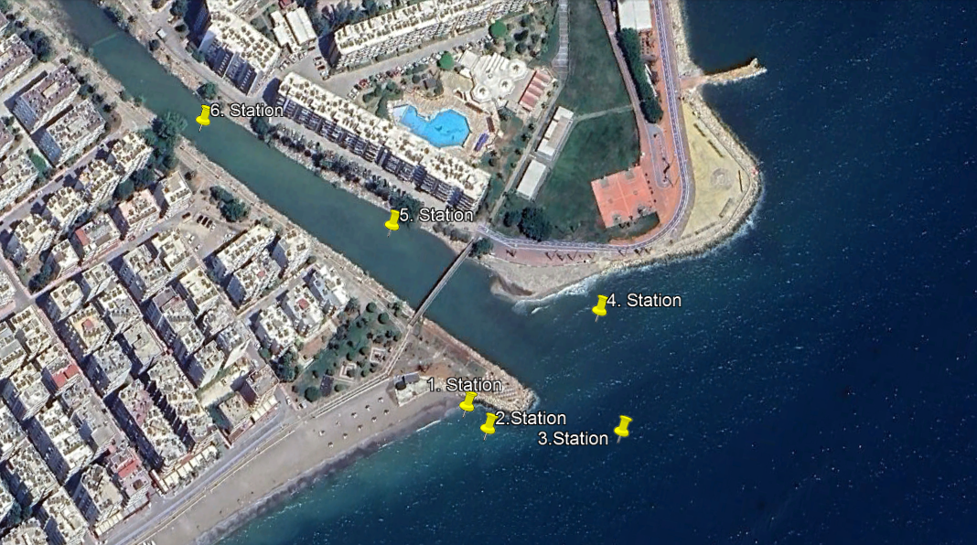Figure 2. Sampling stations along the Mezitli coastal area. A satellite image (Google Maps) showing the positions of six sampling stations (St.1 to St.6) distributed around the mouth of Mezitli Stream and its adjacent coastal zone in Mersin, Türkiye.
Table 1. Geographical coordinates and depths of sampling stations.
Stations | 1. Coordinate plane | 2. Coordinate plane | Depth (m)  Dry season | Depth (m)  Wet season
1. İstasyon | 36°45'0.19N | 34°32'53.04"E | 1.5 m | 1.5 m
2. İstasyon | 36°44'59.90"N | 34°32'53.56"E | 2.5 m | 2.5 m
3. İstasyon | 36°45'0.29"N | 34°32'56.29"E | 3 m | 3 m
4. İstasyon | 36°45'2.19"N | 34°32'55.36"E | 2.5 m | 2.5 m
5. İstasyon | 36°45'2.93"N | 34°32'50.70"E | 0.5 m | 1.5 m
6. İstasyon | 36°45'4.07"N | 34°32'46.24"E | 0.5 m | 1 m

RESULTS AND DISCUSSION
A comprehensive analysis of samples collected from six stations at the mouth of the Mezitli Stream revealed substantial seasonal and depth-dependent variations in macrozoobenthic communities. The most prevalent taxa identified were classified into the phyla Annelida, Arthropoda, and Mollusca, with the most abundant classes comprising Polychaeta (Annelida), Crustacea (Arthropods), and Gastropoda (Mollusca) (Table 2). A decline in species richness and diversity was observed at nearshore stations, which exhibited lower oxygen levels and altered sediment structures. In contrast, offshore stations exhibited higher species diversity, concomitant with enhanced oxygen availability and improved sediment conditions. Seasonal patterns also played a pivotal role: during spring and summer, reduced water inflow and increased agricultural runoff contributed to a decrease in macrozoobenthic abundance and diversity. In contrast, the autumn and winter seasons exhibited augmented species richness, attributable to heightened water input and enhanced oxygen distribution within the water column and benthic layers.
As illustrated in Table 2, a clear distinction in species distribution emerges across the six sampling stations during the dry season, accompanied by significant disparities in both abundance and community structure. A total of 109 individuals representing 18 species were recorded. Station 2 exhibited the highest number of individuals (39) and the highest dominance value (2.588), indicating a less even distribution with a few species dominating the assemblage. In a similar manner, Station 3 exhibited comparatively elevated population levels (28 individuals), accompanied by marginally enhanced evenness (dominance: 2.484). In contrast, Stations 1 and 4, each with 16 individuals, exhibited lower dominance values (1.890 and 1.927, respectively), indicative of a more balanced and moderately diverse community structure. The poorest ecological conditions were observed at Stations 5 and 6, where only five individuals were recorded at each site, and the dominance values were found to be very low (0.950 and 0.500, respectively). These findings suggest that the environment at these stations is highly degraded, and that only a limited number of tolerant species, such as Nereis sp., were able to survive. In comparison, ecologically sensitive species such as Mangelia sp., Alvania discors, and Cerithium scabridum were more frequently found in Stations 2 and 3. The results of the study indicate that macrozoobenthic diversity and abundance were significantly lower in shallow or polluted areas during the dry season. In contrast, offshore or less impacted sites supported more stable and diverse communities.
Table 2. Distribution of benthic macroinvertebrates and Shannon-Weaver Diversity Index results in the dry season according to stations
Number | Names of species | Station  1 | Station  2 |  | Station  3 | Station  4 | Station  5 | Station  6
1 | Abra sp. | 2 | 1 |  | 0 | 1 | 0 | 0
2 | Alvania discors | 1 | 3 |  | 2 | 0 | 0 | 0
3 | Alvania fractospira | 0 | 0 |  | 3 | 3 | 0 | 0
4 | Cerithium scabridum | 1 | 3 |  | 2 | 4 | 0 | 0
5 | Cerithium sp. | 3 | 3 |  | 0 | 1 | 1 | 1
6 | Conomurex persicus | 0 | 1 |  | 0 | 0 | 0 | 0
7 | Corbula gibba | 0 | 4 |  | 3 | 0 | 0 | 0
8 | Donax sp. | 5 | 3 |  | 2 | 2 | 0 | 0
9 | Donacilla cornea | 2 | 3 |  | 0 | 3 | 0 | 0
10 | Mangelia sp. | 0 | 4 |  | 4 | 0 | 0 | 0
11 | Ringicula auriculata | 1 | 4 |  | 3 | 0 | 0 | 0
12 | Nereis sp. | 0 | 0 |  | 0 | 0 | 3 | 4
13 | Ocenebra sp. | 0 | 1 |  | 1 | 0 | 0 | 0
14 | Parvicardium scriptum | 0 | 4 |  | 2 | 1 | 0 | 0
15 | Timoclea ovata | 1 | 0 |  | 1 | 1 | 0 | 0
16 | Pusillina lineolata | 0 | 3 |  | 2 | 0 | 1 | 0
17 | Tellina sp. | 0 | 1 |  | 1 | 0 | 0 | 0
18 | Tritia pygmaea | 0 | 1 |  | 2 | 0 | 0 | 0
Dominance |  | 1.890 | 2.588 |  | 2.484 | 1.927 | 0.950 | 0.500
Total number of individuals per station |  | 16 | 39 |  | 28 | 16 | 5 | 5
Total number of individuals in all stations |  |  |  | 109

The results of the AMBI analysis applied to macrozoobenthic species sampled during the dry season are summarized in Table 3. AMBI is a widely used ecological index for assessing the quality of marine and estuarine sediment based on the presence and abundance of benthic macroinvertebrates. These organisms are classified according to their tolerance to pollution. The table presents the percentage compositions of species sensitivity groups (I–VI), AMBI scores, and additional biodiversity indicators, including Shannon-Wiener Diversity (H'), Species Richness, and M-AMBI (Multivariate-AMBI).
Table 3. AMBI (AZTI Marine Biotic Index) biotic index values of sampling data in the dry season.
Stations | I  (%) | II  (%) | III  (%) | IV  (%) | V  (%) | IV  (%) | AMBI | AMBI (Mean) | BI AMBI (Mean) | Std  Deviation
Station 1 | 53.33 | 33.33 | 13.33 | 0.00 | 0.00 | 6.30 | 0.90 | 2.073 | 2 | 1.72
Station 2 | 44.12 | 41.18 | 2.94 | 11.77 | 0.00 | 12.80 | 1.24
Station 3 | 47.83 | 39.13 | 0.00 | 13.04 | 0.00 | 17.90 | 1.17
Station 4 | 62.50 | 31.25 | 6,25 | 0.00 | 0.00 | 0.00 | 0.66
Station 5 | 20.00 | 60.00 | 60.00 | 90.00 | 0.00 | 0.00 | 3.70
Station 6 | 0,00 | 82.00 | 96.8 | 0.00 | 0.00 | 0.00 | 4.772
 | AMBI | Diversity |  | Richness |  | X | Y | Z | M-AMBI | Status
Bad | 6,0 | 0 |  | 0 |  | 24.496 | 24.494 | 0 | 0 | Bad
High | 16.803 | 35.855 |  | 18 |  | -12.247 | -12.246 | 0 | 1 | High
NaN | 14.609 | 39.814 |  | 18 |  | -12.249 | -12.248 | 0 | 1 | High

The ecological quality assessment, which is based on AMBI scores and species sensitivity groups, reveals a distinct gradient of environmental health across the six sampling stations. Station 1 exhibits high ecological quality, marked by a preponderance of sensitive species from Group I (53.33%) and an AMBI score of 0.90, indicative of minimal disturbance. Stations 2 and 3 also exhibited favorable ecological conditions, characterized by moderate dominance of Group I and II species and minimal representation of tolerant taxa. This resulted in AMBI values of 1.24 and 1.17, respectively. Station 4 is distinguished by its notably high proportion of Group I species (62.50%) and its low AMBI score (0.66). This suggests that the ecosystem at Station 4 is of exceptionally high quality and has been impacted to a minimal extent. Conversely, Station 5 exhibited indications of environmental degradation, characterized by an increasing prevalence of tolerant species (60% in Group III) and a moderate AMBI score of 3.70, indicative of a transition toward a more disturbed community structure. Finally, Station 6 is the most degraded site, exhibiting a complete absence of sensitive species and extreme dominance by tolerant and opportunistic taxa (96.80% in Group III). This is accompanied by the highest AMBI score of 4.77, indicating a poor ecological status. These findings underscore the efficacy of AMBI in detecting subtle to severe anthropogenic impacts on benthic communities (Table 3).
The Shannon-Wiener diversity index (H') is a measure of species richness and evenness. When values approach zero, as is the case at the "poor" station, it is indicative of a markedly low level of biological diversity. Higher values, such as 35,855 and 39,814, observed in the "high" stations, indicate the presence of rich and balanced ecosystems. The species richness, defined as the number of different taxa present, further substantiates this distinction. Stations classified as "high" host 18 species, indicating higher biological complexity. The M-AMBI index is a composite index that integrates the AMBI score with diversity and richness to provide a comprehensive assessment of ecological condition. In this particular dataset, stations with M-AMBI values of 1 are indicative of high ecological conditions, while values of 0 correspond to degraded "poor" stations (Table 3).
As illustrated in Table 4, the distribution of benthic macroinvertebrate species was examined across a total of six sampling stations during the wet season at the mouth of Mezitli Stream. A total of 34 species were documented, with individual counts provided for each station. Stations 1 to 4 exhibited higher species richness and total individual counts, indicating more favorable ecological conditions. Among the stations, Station 3 exhibited the highest abundance (58 individuals) and the highest dominance index (3.14), indicative of a well-balanced and diverse community structure. Conversely, Stations 5 and 6 exhibited diminished diversity and abundance, indicating potential ecological stress. It is noteworthy that Station 6 exhibited the lowest number of individuals (12) and the lowest dominance index (1.234), indicative of suboptimal habitat quality. Pollution-tolerant species, including Nereis sp., Hediste diversicolor, and Corbula gibba, were predominantly observed in the more degraded Stations 5 and 6. In contrast, species such as Tellina sp., Tritia pygmaea, Mitromorpha olivoidea, and Mangelia sp. exhibited higher abundance in Stations 1 to 3, indicating healthier zones. The values of the dominance index are indicative of species evenness and distribution: lower values suggest communities that are more balanced and diverse, whereas higher values reflect a dominance by fewer species. The total number of individuals across all stations was 211, which supports the observation that benthic productivity and species abundance increased during the wet season. This increase is likely due to improved oxygenation and organic matter availability. This table underscores the spatial variability in benthic communities and emphasizes the ecological impact of environmental conditions during seasonal changes.
Table 4. Distribution of benthic macroinvertebrates in the wet season according to stations.
Number | Names of species | Station 1 | Station 2 | Station 3 | Station 4 | Station 5 | Station 6
1 | Abra sp. | 2 | 4 | 1 | 1 | 0 | 0
2 | Alvania discors | 2 | 2 | 4 | 3 | 1 | 0
3 | Cerithium sp. | 2 | 1 | 2 | 3 | 1 | 0
4 | Columbella sp. | 1 | 0 | 1 | 0 | 0 | 0
5 | Conomurex persicus | 0 | 2 | 0 | 1 | 0 | 0
6 | Conus sp. | 0 | 0 | 1 | 0 | 0 | 0
7 | Corbula gibba | 2 | 4 | 3 | 3 | 1 | 0
8 | Donacilla cornea | 0 | 1 | 1 | 0 | 0 | 0
9 | Donax sp. | 0 | 0 | 2 | 0 | 0 | 0
10 | Granulina sp. | 0 | 1 | 1 | 0 | 0 | 0
11 | Hediste diversicolor | 0 | 0 | 0 | 0 | 2 | 1
12 | Lumbrineris latreilli | 0 | 0 | 0 | 0 | 1 | 2
13 | Donacilla cornea | 3 | 2 | 3 | 1 | 1 | 0
14 | Mangelia sp. | 3 | 2 | 4 | 2 | 1 | 1
15 | Ringicula auriculata | 0 | 1 | 0 | 0 | 0 | 0
16 | Mitromorpha olivoidea | 5 | 2 | 4 | 0 | 1 | 0
17 | Musculus costulatus | 0 | 1 | 2 | 0 | 0 | 0
18 | Nereis sp. | 0 | 0 | 0 | 1 | 5 | 7
19 | Obtusella intersecta | 0 | 2 | 0 | 2 | 1 | 1
20 | Ocenebra sp. | 2 | 3 | 4 | 2 | 1 | 0
21 | Odostomia sp. | 4 | 2 | 2 | 1 | 0 | 0
22 | Ostrea sp. | 0 | 0 | 1 | 0 | 0 | 0
23 | Parvicardium scriptum | 0 | 4 | 3 | 0 | 0 | 0
24 | Patella sp. | 0 | 2 | 2 | 0 | 0 | 0
25 | Similipecten similis | 0 | 0 | 1 | 0 | 0 | 0
26 | Pitar rudis | 4 | 5 | 2 | 2 | 0 | 0
27 | Timoclea ovata | 2 | 1 | 2 | 1 | 0 | 0
28 | Pusillina lineolata | 1 | 2 | 0 | 2 | 0 | 0
29 | Raphitoma sp. | 0 | 3 | 2 | 1 | 0 | 0
30 | Rissoa sp. | 0 | 0 | 2 | 0 | 0 | 0
31 | Septifer cumingii | 0 | 0 | 1 | 0 | 0 | 0
32 | Tellina sp. | 3 | 2 | 4 | 2 | 1 | 0
33 | Tritia pygmaea | 1 | 5 | 3 | 2 | 1 | 0
34 | Ruditapes decussatus | 0 | 2 | 0 | 0 | 0 | 0
Dominance |  | 2.602 | 3.051 | 3.14 | 2.748 | 2.366 | 1.234
Total number of individuals per station |  | 37 | 56 | 58 | 30 | 18 | 12
Total number of individuals in all stations |  | 211

As illustrated in Table 5, an analysis of the ecological quality of sampling stations during the wet season is facilitated by the application of the AMBI index in conjunction with supporting biodiversity indicators. AMBI is a method of evaluating the response of benthic macroinvertebrate communities to environmental disturbance. It involves the classification of species based on their tolerance for pollution. The following table presents the percentages of species grouped by sensitivity levels (Groups I–VI), AMBI scores, and additional metrics including Shannon-Wiener Diversity (H'), Species Richness, and M-AMBI (Multivariate-AMBI).
Table 5. AMBI biotic index values of sampling data in wet season
Stations | I  (%) | II  (%) | III  (%) | IV  (%) | V  (%) | IV  (%) | AMBI | AMBI (Mean) | BI AMBI (Mean) | Std  Deviation
Station 1 | 43.243 | 45.946 | 5.405 | 5.405 | 0 | 0 | 1.095 | 1.393 | 2 | 0,6
Station 2 | 58.182 | 27.273 | 7.273 | 7.273 | 0 | 1.8 | 0.955
Station 3 | 60.345 | 31.034 | 3.448 | 5.172 | 0 | 0 | 0.802
Station 4 | 40 | 43.333 | 6.667 | 10 | 0 | 0 | 1.3
Station 5 | 27.778 | 27.778 | 38.889 | 5.556 | 0 | 0 | 1.833
Station 6 | 8.333 | 25 | 66.667 | 0 | 0 | 0 | 2.375
 | AMBI | Diversity |  | Richness |  | X | Y | Z | M-AMBI | Status
Bad | 6 | 0 |  | 0 |  | 24 | 0 | 0 | 0 | Bad
High | 14.246 | 25.29 |  | 34 |  | -12.25 | 0 | 1 | 1 | High
NaN | 13.932 | 46.95 |  | 34 |  | -12.25 | 0 | 1 | 1 | High

The ecological quality assessment conducted during the wet season reveals a clear gradient in environmental health across the sampling stations. Stations 1 to 4 demonstrate high to very high ecological quality, indicative of a robust presence of sensitive and less-tolerant species. For instance, Station 1 is characterized by 43.24% Group I and 45.95% Group II species, yielding a low AMBI score of 1.095. Furthermore, Stations 2 and 3 exhibited an elevated prevalence of sensitive taxa, with Group I species constituting over 58% of the total, and correspondingly low AMBI values of 0.955 and 0.802, respectively, suggesting minimal environmental disturbance. Station 4 has been found to demonstrate favorable ecological status, exhibiting 40% Group I and 43.33% Group II species, which collectively yield an AMBI score of 1.30. Conversely, Stations 5 and 6 exhibit an evident transition toward moderate to poor ecological conditions. Station 5 demonstrates a balanced composition of Group I and II species, yet it exhibits a notable presence of Group III (tolerant) species, accounting for 38.89% of the total. This contributes to an elevated AMBI score of 1.833. The most degraded condition is observed in Station 6, where tolerant taxa dominate (66.67% in Group III) and sensitive species are nearly absent, resulting in the highest AMBI score of 2.375. These findings underscore the mounting ecological stress in select regions and accentuate the sensitivity of AMBI in detecting the impacts of pollution on benthic communities during the wet season (Table 5).
The complementary indices for the wet season further corroborate the ecological assessments derived from AMBI values. The Shannon-Wiener Diversity Index (H') demonstrates significant variability, with elevated values, such as 46.95, observed in stations designated as "High" status. These elevated values are indicative of a well-balanced and evenly distributed species composition, which is a hallmark of a healthy and stable ecosystem. Furthermore, the wet season exhibits a notable increase in species richness, with 34 distinct species documented at high-status stations, underscoring the profound biological complexity and diversity characteristic of these environments. The M-AMBI index, which integrates AMBI, diversity, and richness into a comprehensive metric, has been shown to register a value of 1 at these high-quality sites, thereby confirming their robust ecological condition. In stark contrast, the station designated as "Bad" exhibits pronounced ecological degradation, with an AMBI score of 6.0, an absence of diversity (H' = 0.0), and zero species richness, resulting in an M-AMBI value of 0 (Table 5).
The results of the AMBI analyses conducted during both the dry and wet seasons reveal seasonal variations in the ecological quality of the sampling stations. In both periods, Stations 1 to 4 exhibited consistent high ecological quality, characterized by the prevalence of sensitive species (Groups I and II) and low AMBI scores. It is noteworthy that during the wet season, these stations exhibited even lower AMBI values and increased species richness, suggesting that environmental conditions may have become more favorable for benthic communities. Conversely, Stations 5 and 6 exhibited persistent indications of ecological degradation across both seasons. Station 6, in particular, exhibited a prevalence of tolerant taxa (Group III) and elevated AMBI scores during both the dry (AMBI = 4.77) and wet (AMBI = 2.375) seasons, accompanied by diminished diversity and richness values. The M-AMBI index further corroborated these patterns, with a value of 1 in high-quality stations and 0 in severely impacted ones during both seasons (Table 3, 5). In summary, the present findings underscore the effectiveness of AMBI and M-AMBI as reliable biological tools for monitoring seasonal ecological changes in benthic environments.
Sediment analysis employing the oxidation-reduction potential (ORP) method further elucidated spatial variability, which was found to be associated with redox conditions. Lower ORP values were predominantly measured near stations influenced by the Mezitli Stream, indicating reduced oxygen availability and more anaerobic sediment environments. In contrast, offshore stations exhibited higher ORP values, consistent with less reduced and more oxygenated conditions. The results of the study indicated an inverse correlation between ORP values and the concentration of organic pollutants. This suggests that ORP values may serve as a proxy for oxidative capacity and the degradation potential of contaminants. The application of seasonal comparisons of ORP values, as demonstrated in Table 6, offers insights into the dynamic redox environment during periods of both dry and wet conditions.

Table 6. ORP values ​​for the dry and wet seasons
Stations | Dry season (-mV) | Wet season (-mV)
Station 1 | -82.1 | -72.30
Station 2 | -84.1 | -70.60
Station 3 | -69.7 | -61.70
Station 4 | -164.8 | -149.4
Station 5 | -197.9 | -182.0
Station 6 | -242.4 | -202.1
The findings of this study demonstrate that the benthic ecosystem at the mouth of Mezitli Stream exhibits heightened sensitivity to coastal pollution, a finding that aligns with prior research conducted in Mersin Bay and along the Mediterranean coast (Çınar, 2004; Kazancı, Girgin, Dügel, & Oğuzkurt, 1997). Consistent with global observations, the study corroborated the notion that the accumulation of organic matter and anthropogenic inputs, particularly from agricultural and urban sources, exert a deleterious effect on macrozoobenthic community diversity (Allan, Bain, Pestegaard, Richter, & Sparks, 1997; Rosenberg & Resh, 1992).
Stream mouths are defined as ecologically dynamic habitats that are enriched by the influx of nutrients and organic matter. Brackish water environments, which are created by the interaction between freshwater and seawater, support high biodiversity. However, these environments are acutely vulnerable to anthropogenic stressors. Macrozoobenthic fauna, acting as pivotal mediators in energy flow within aquatic food webs, serve as critical indicators of ecosystem functioning. Their evaluation in terms of abundance, biomass, and diversity is vital for assessing ecological integrity and guiding conservation strategies.
This study provided a comparative assessment of macrozoobenthic communities across dry and wet seasons and at varying depths. Seasonal variation exerted a pronounced influence on community structure. During periods of drought, diminished water levels and reduced organic input, correlated with low precipitation, have been observed to result in the depletion of nutrients and the subsequent decrease in oxygen availability. This, in turn, has led to constraints in reproductive and developmental conditions for numerous species. Conversely, wet seasons led to increased freshwater inflow, higher organic loads, and improved oxygen distribution, resulting in a significant increase in both species abundance and diversity. In certain locations, population levels exhibited a doubling compared to the dry season.
Station-specific analyses further revealed spatial heterogeneity. Station 2 exhibited elevated diversity during the dry season, likely attributable to its greater depth, enhanced current exposure, and higher nutrient and oxygen availability. Station 3 demonstrated the highest degree of diversity during the rainy season, a phenomenon attributed to its proximity to the open sea, enhanced light penetration, and favorable conditions for nutrient accumulation and oxygenation.
However, despite the occurrence of temporary increases in diversity due to algal blooms in shallow areas during summer, subsequent oxygen depletion in deeper layers caused by sulfide accumulation disrupted the benthic ecosystem. This phenomenon has led to the predominance of species that are capable of tolerating pollution, such as Nereis sp., which is particularly prevalent in low-oxygen zones.
ORP (Oxidation-Reduction Potential) analyses confirmed that the benthic sediment structure harbors a significant pollution load, with biological activity in detritus-rich zones notably suppressed. These findings suggest that the freshwater input from Mezitli Stream carries a high burden of anthropogenic pollutants.
The macrozoobenthic diversity of the region is predominantly influenced by factors such as pollution, climate change, and habitat modification. Anthropogenic discharges from agricultural, industrial, and domestic sources have been shown to degrade water quality and community structure. Rising water temperatures have been shown to alter species distribution patterns, while coastal development and dredging have been demonstrated to disrupt habitat integrity and reduce biodiversity.
These results underscore the pressing need for routine ecological monitoring and targeted pollution control measures to ensure the preservation of the Mezitli Stream ecosystem. Moreover, the findings provide a scientific foundation for sustainable management practices and could serve as a model for other coastal systems experiencing anthropogenic stress.
Acknowledgment
This study was supported by the Research Fund of Mersin University in Türkiye with Project Number: 2023-2-TP2-4964.

Author Contributions
Writing - original draft, sampling, methodology, writing - review and editing: CK, ÖŞ, Conceptualization, Investigation, visualization, editing: DA, AAA, original draft, writing - review and editing, final check control: DE, MCA.
Conflicts of Interests
The authors declare that for this article, they have no conflict of interest.
Ethical Approval Statements
There is no ethical issue concerning this article.
Data Availability Statement
All data associated with this study are presented in the article.

REFERENCES

Agarwal, A., & Bui, A. D. (2017). Oxidation-reduction potential as a new marker for oxidative stress: Correlation to male infertility. Investigative and clinical urology, 58(6), 385-399.
Allan, J., Bain, M., Pestegaard, K., Richter, B., & Sparks, R. (1997). The natural flow regime: A paradigm for river conservation.
Borja, A., Chust, G., & Muxika, I. (2019). Forever young: the successful story of a marine biotic index. Advances in marine biology, 82, 93-127.
Borja, A., & Muxika, I. (2005). Guidelines for the use of AMBI (AZTI’s Marine Biotic Index) in the assessment of the benthic ecological quality. Marine pollution bulletin, 50(7), 787-789.
Çınar, M. E. (2004). Ege denizinde dağılım gösteren bir sünger türü (Ircinia muscarum Schmidt 1864) ile birlik oluşturan poliketlerin taksonomik ve ekolojik yönden araştırılması. Fen Bilimleri Enstitüsü.
de Almeida, T. C. M., Arana, P. M., Sant’Ana, R., & Pezzuto, P. R. (2016). A new benthic macrofauna and sediments sampler for attaching to otter trawl nets: comparison with the Van Veen grab. Latin american journal of aquatic research, 44(5), 1116-1122.
Douterelo, I., Perona, E., & Mateo, P. (2004). Use of cyanobacteria to assess water quality in running waters. Environmental Pollution, 127(3), 377-384.
Dudgeon, D., Arthington, A. H., Gessner, M. O., Kawabata, Z.-I., Knowler, D. J., Lévêque, C., . . . Stiassny, M. L. (2006). Freshwater biodiversity: importance, threats, status and conservation challenges. Biological reviews, 81(2), 163-182.
Ge, J., Chen, J., Zi, F., Song, T., Hu, L., He, Z., . . . Li, H. (2025). Seasonal Variations in Macrobenthos Communities and Their Relationship with Environmental Factors in the Alpine Yuqu River. Biology, 14(2), 120.
Kazancı, N., Girgin, S., Dügel, M., & Oğuzkurt, D. (1997). Akarsuların çevre kalitesi yönünden değerlendirilmesinde ve izlenmesinde biyotik indeks yöntemi. Türkiye İç Suları Araştırmaları Dizisi, 100.
Kunakh, O., Volkova, A., Tutova, G., & Zhukov, O. (2023). Diversity of diversity indices: which diversity measure is better? Biosystems Diversity, 31(2), 131-146.
Özay, B., & Orhan, O. (2023). Flood susceptibility mapping by best–worst and logistic regression methods in Mersin, Turkey. Environmental Science and Pollution Research, 30(15), 45151-45170.
Rosenberg, D. M., & Resh, V. (1992). Freshwater biomonitoring using individual organisms, populations, and species assemblages of benthic macroinvertebrates. Freshwater biomonitoring and benthics macroinvertebrates. Chapman & Hall, New York, USA, 40-158.
Vinson, M. R., & Hawkins, C. P. (1998). Biodiversity of stream insects: variation at local, basin, and regional scales. Annual review of entomology, 43(1), 271-293.
Wallace, J. B., & Webster, J. R. (1996). The role of macroinvertebrates in stream ecosystem function. Annual review of entomology, 41(1), 115-139.

